

**1805 N. Atherton Street, State College, PA 16803**

**Spring**

12

Jump Right InDEX

the

08

**Fall**

**The new way of staying cool in the pool business**

**Tom Lutz**

**Program Director**

**Jacqueline Layer**

**Chief Editor**

**Bre Hawras**

**Operations Manager**

**Sean Gauslin**

**Business Consultant**

**Kyle Gibson**

**Forecast Analyst**

**Let Us Introduce Ourselves**  
 Elite Weather Enterprises is comprised of Penn State graduates who have a strong interest in not only weather, but in business as well.  We have a combined total of 15 years of forecasting experience as well as an employee who has had personal working experience at Leslie’s.  With this much forecasting experience under our belts, we have been able to see the effects of accurate, as well as inaccurate, forecasts for businesses everywhere.  We have concluded that weather can make or break a business. So, not only do we know meteorology, but we understand how your business works and what you strive to achieve.

**What Elite Weather Enterprises can provide**

As Elite Weather Enterprises, our primary goal is developing weather indexes that will be useful to a company’s everyday business endeavors. Meteorologists develop weather indexes as a tool for businesses, as well as the public, to be able to plan in advance for a particular event or situation without consulting meteorologists or local weather forecasts on a daily basis. The weather index we developed for Leslie’s will help save the company thousands of dollars which could be put towards other aspects of the company, like advertising or labor. It will be able to provide Leslie’s Pool Company with a simple, yet crucial summary of daily and seasonal weather variables. No pool business can be successful without a complete understanding of the weather. Our index would insure that proper stores are being shipped and stocked with the correct volume of pool supplies. For example, a branch of the company in Florida will need a lot more chemicals than a branch of the company in Pennsylvania. Why? Weather of course! Everything in the pool business boils down to weather, and our services will help the company become more efficient in distribution and sales.

Weather indexes, in general, are composed of meteorological data converted into a formula, then relayed to the public or in this case, relayed to a company which can help make risky decisions with more ease. The index will allow a company to ship products to stores that are in a greater need of the merchandise. For example, if the forecast is calling for warm, sunny weather at the beginning of summer in New Jersey, the company will want to ship the best products and chemicals needed to open pools to the stores in that area. The index will also assist with employee schedules by helping the company decide if they need to call extra employees in for a particular weather event or if they can give them the day off.

**Why are weather indexes needed?**

A very important index that is often used in warm states over the summer is the heat index. The heat index is calculated using two variables; temperature and relative humidity. Then, the index is put into a formula and calculates the temperature that is felt on your bare skin. The heat index can be used to access the danger of working outside due to excess heat. For example, if the actual temperature was 95 degrees and the humidity was 60%, the temperature actually felt, when plugged into the heat index formula, would be 113 degrees Fahrenheit. This is quite dangerous if one was outside for an extended period of time.

Some other indexes that are used quite frequently and are needed to save people’s lives are the Wind Chill Index, the Tor Con index, and the UV Index. Each one of these is very helpful in their own way. The Wind Chill combines the temperature and wind to let the public know the temperature that is felt on their bare skin. Once the combination between wind and temperature hits a certain Wind Chill temperature, it is no longer safe to remain outside for an extended period of time before frostbite becomes apparent.

The Tor Con index is the percent chance of a tornado occurring within 50 miles of your location. This helps homeowners to prepare their family, houses, and property for an impending tornado.

Lastly, the UV index measures the strength of the ultraviolent rays at a particular time. It allows people to apply the correct sun care lotions to their skin so they will not burn. This helps the general public reduce their risk of sun poisoning and freckles. Reducing their risk of these dangerous exposures could save them from possible skin complications.

The world of meteorology has significantly advanced in the last 10-20 years due to the advance of technology and research. This has lead to huge strides in improving computer model forecasts known as Numerical Weather Prediction. These models have improved as a result of better handling of radar and satellite data. Not only have meteorologists made advancements in weather data on land, but more buoy and station model reports have been placed over the oceans which allows scientists to make much more concrete forecasts. The United States has three significant coastlines, the Pacific, Atlantic, and the Gulf Coast. If we did not know what was going on off these coasts, it could throw off the forecast. These observations give us a better look at weather systems before they come on shore and how they could affect us. New satellites have been put into place in the last 10 years that give us high-definition visual detail of a storm system from space. A business of meteorology now has the upper hand in extremely sophisticated forecasting.

All of these developments have led to higher resolution and greater accuracy in models like the NAM, GFS, and European. The NAM (North American Mesoscale Model) displayed the 24 km resolution a few years ago and has improved to grid point spacing at 12 km. Just this year, the latest version of the model was released and now the resolution is down to four km. The NAM works by solving forecast equations at the grid points every four kilometers. As the resolution increases (or in other words, the distance from each grid point decreases), it allows meteorologists to develop better forecasts, leading to a better overview of the weather. Therefore, with more data, the model can produce better temperature and precipitation forecasts. The latest four km model is able to pick up on individual thunderstorms cells that could develop in the next day or two. The model also allows us to see the effects of topography, especially on rain totals. Consequently, you can see why it is so vital that the resolution of the model has increased, as it gives a higher degree of forecasting accuracy as shown in the chart below.

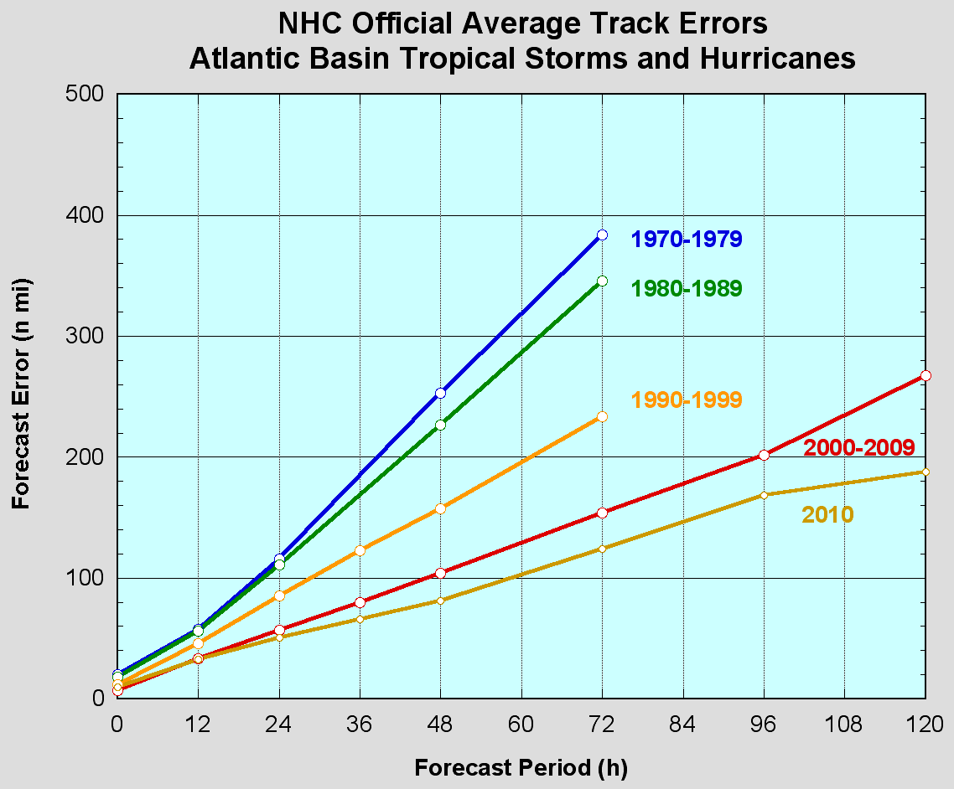

*Average forecast Error of the Location of hurricanes (Courtesy National Hurricane Center)*

The chart above shows just how far we have come in forecasting since the 1970’s. It shows the average forecast error of the location of a hurricane a certain amount of days out. In the 1970-79 time frame, you can see the average track error was about 120 miles in 24 hours. Then in the 1990-99 time frame, the National Hurricane Center, NHC, was able to bring the error down to 80 miles. Then, in 2010, with the use of better models and better resolution of hurricanes, the average error was just off by 50 miles! This has improved immensely in the last 25 years, which allows meteorologists to have a much better handle on predicting these weather systems. The same case can be made for a three day tropical forecast, when in 1980-89 the average error was more than 200 miles off. However, today the average for a five day tropical forecast out is not even 200 miles.

It is only 180 miles that shows how greatly these forecasts have improved. This information could be very useful in Florida, Texas and essentially anywhere in the south where Leslie’s has the vast majority of their stores. It would be crucial for the company to know a hurricane was coming 3-5 days in advance so they could prepare their stores and inventory for the possible damage associated with the storm.

The ensemble models allow for any changes or uncertainly in the forecast to be accounted for. This combination provides a range of possibility to scientists. The most accurate model will be used by scientist to clearly display the forecast. The ensembles run on several models by making slight changes in the variables to account for change that could happen over the next several forecast days. They are able to account for possible errors in the initial conditions that are being used to run the models. This could include station report errors or inaccurate atmospheric data being fed into the models. Meteorologists gain a huge advantage in forecasting when they are able to know the worst and best-case scenario that can happen in a forecast. When meteorologist use ensembles to forecast they can be much more certain about an event occurring if the majority of the models are leaning towards a certain event. In developing an index, scientists will have a higher confidence that it will be accurate and reliable.

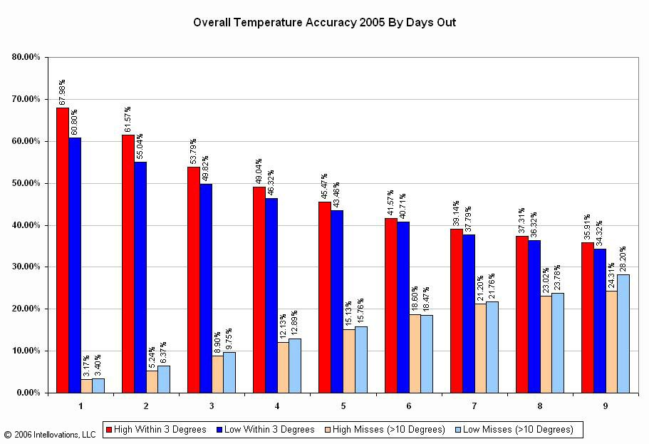 *Overall Temperature Accuracy for a day (Courtesy Forecast Advisor)*

This gathered data allows scientists to make very accurate temperature forecast for several days out, as seen in the graph above. For a one day forecast, 70% of the time the high temperature is within three degrees of what was predicted. For a three day forecast the high temperature is within 3 degrees about 53% of the time. However, the low temperature is generally off more than the high temperature because other factors come into play once the sun goes down making the low temperature harder to forecast. Localized cloud cover and wind greatly affect the temperature, and are quite hard to forecast because they can vary vastly over small areas. These improvements are huge because 20 years ago a two day forecast is now as accurate as 5 day forecast.

[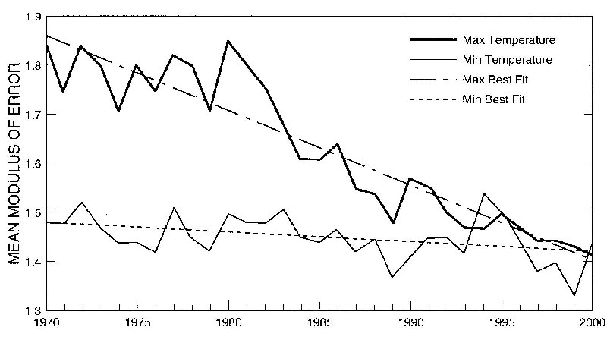](http://rds.yahoo.com/_ylt=A0PDoX9ejRdPGygA5t6jzbkF;_ylu=X3oDMTBpcGszamw0BHNlYwNmcC1pbWcEc2xrA2ltZw--/SIG=12ivg6n76/EXP=1326972382/**http:/www.bom.gov.au/inside/eiab/reports/ar00-01/wxserv.shtml)( Courtesy Australian Government of Meteorology)

This graph helps further show how meteorologists have become much better at forecasting. It displays the mean modulus of error, which is the average error from the high and low temperature that was forecasted in °C. During the last 30 years you can see huge strides have been made in forecast accuracy. In 1970 the error was about 3 °F for the high temperature and today that error is down to 2.2 °F. The same pattern occurs with the low temperature but the drop is not as significant. During the 1980’s you can see the graph started a steady decline. This was due to the advancement of computer models and education of meteorologists. The science of meteorology was beginning to become the prestigious, world-wide science it is today.

The computer models have their limit, so meteorologists need to interpret the data and come up with a trustworthy forecast. Our studies at Penn State have allowed us to become the most dependable and reliable meteorologists for developing an accurate index. With computer models and technology’s continual improvement the science behind an index can only advance.

**What we know about Leslie’s and the Industry**

Leslie’s Poolmart Inc. is part of a $5.0 billion dollar a year industry and is the leader in selling and supplying everything from pool and spa chemicals, to filter parts, to pool toys, to high quality maintenance and repair services, to pools and spas themselves. Leslie’s Poolmart is comprised of 622 stores in 35 states, making it the largest company of its kind in the United States with total sales now exceeding $500 million. Competitors only make up about one third of the size of Leslie’s, and most of them are “mom and pop” stores. Due to having some of the largest populations of all the 50 states and enduring some of the longest periods of warm weather, it is no surprise that Arizona, California, Florida, and Texas have the most stores located within their borders.

All pool owners love to have a clean pool or spa, and Leslie’s helps them achieve this. Most pool owners know that a pool uses chemicals to keep the pool clean and in “chemical balance”. If this chemical balance is neglected, green algae, black algae, mineral and salt saturation, eye irritation, over chlorinating, staining, and corrosive water can occur. This is where the experts at Leslie’s come in. Leslie’s has been providing expertise in the pool industry for dozens of years. In order to continue Leslie’s great reputation in the pool industry, we are here to help by aiding in supplying the best products at the most convenient time for your customers.

All major companies are looking to expand and improve sales in every way that they can. With online sales on its webpage ([www.Lesliespool.com](http://www.Lesliespool.com)), we know Leslie’s is staying competitive not only on the local level, but on the cyber level as well. This webpage provides private companies and the public with thousands of items that may not be available in stores. This allows Leslie’s to be accessed by customer’s who are not necessarily close to a Leslie’s store and makes Leslie’s even more competitive within the pool industry.

Leslie’s has also reached out to consumers through their mailboxes, too. According to the United States Securities and Exchange Commission form 10-K, Leslie’s has been able to expand their mailing list by having in-store signups and giveaways to keep their consumers coming back. Their mailing list is approaching 10 million residents.

As Leslie’s is expanding, so is the amount of pools in the United States per year. According to the research firm P.K. Data, the amount of pools will exceed 10 million in 2012 and continue to increase in numbers from there. With the amount of pools increasing over time, Leslie’s is going to see many opportunities to increase their profits. The goal of our index revolves around this idea and leads to two simple questions:

1. How can we save Leslie’s money?
2. How can we help make Leslie’s money?

We know Leslie’s has several distribution centers located in New Jersey, California, Kentucky, Texas, and Florida. We also know that Leslie’s sends their shipments to each of its stores every 5 to 7 days. Without these shipments, stores could run out of product, which ultimately could lose the company money, making this the most important aspect of a company. Luckily for Leslie’s, shipping is highly dependent on several weather variables, which our weather index takes into account. With the use of our index, Leslie’s will be able to map out the next five days and plan shipping routes to Leslie’s distribution centers. Therefore, Leslie’s could easily see when the ideal times would be to send out shipments and what routes should be taken, potentially saving the company thousands of dollars on trucking, gas, and labor.

According to the 10-K form for 2009, Leslie’s spent a total of around $122,400,000 on operating expenses; half of this was due to labor costs. This means $61,200,000 was the result of other expenses, such as shipping and distribution. Let’s estimate that 10% ($6,120,000) is responsible for shipping and distribution. With the use of our index, Leslie’s can ship their products more efficiently by not wasting money on labor, gas, and time by shipping to a location where Leslie’s won’t have a good sales week. Doing this we may only save Leslie’s maybe 1% ($61,200), however, if Leslie’s did this for at least ten of their stores during the whole year, this will accumulate a savings of $612,000, and the savings can only get better.

Not only will Leslie’s be able to save money on distribution, but also each individual store manager will become even more thrifty when it comes to cutting down on labor costs. According to the 10-K form, Leslie’s essentially spent $61,200,000 on labor costs. When the index is distributed electronically to each store manager, they can determine the amount of labor the store may or may not need for the next several days by analyzing the weather effects on their potential sales for employee schedules. Having a former employee of a Leslie’s store in Brick, New Jersey, we understand that there is always uncertainty of who will be working in a day or two if rain is in the forecast. In many cases, employees are called into work for the day and only work an hour or two before being told they are no longer needed. If our index were in use, the store manager would be able to tell employees with confidence that they would not need to come in if sales were lacking that rainy day. Even if only $30 dollars is saved in one day by 100 stores through planning employee scheduling accordingly, that’s $3000 in total savings. If this was done for several days in relation to using our index, we could help Leslie’s save tens of thousands of dollars on top of what Leslie’s already saves.

Like we have mentioned before, by hiring us to provide you with our innovative index, you are essentially employing a team of specialized meteorologists to provide valuable information to gauge shipments and labor that a single-handed meteorologist with no business background would be unable to provide. According to the Bureau of Labor Statistics, the average salary for meteorologists employed by the Federal Government was $93,661 in March 2009. Our contract, located at the bottom of this document, clearly shows how Leslie’s can save thousands if one of our index packages is purchased.

Now we are going to suggest how Elite Weather Enterprises can actually make Leslie’s money. The concept is actually straightforward. If a company knows where there will be an increase in sales then the company would be able to provide the stores with more products to ensure more money can be made. However, without an index, knowing where these increases are going to occur can be difficult if not impossible. The only other way to forecast is to check websites from providers such as The National Weather Service or AccuWeather, which can be time consuming and sometimes confusing. By using an index, Leslie’s is essentially purchasing a sales forecast perfect for all aspects of the company. If Leslie’s knows where sales are going to skyrocket in relation to a weather pattern, then they can ship more products to that region in preparation.

From an employee of EWE’s personal experience while working at Leslie’s on consecutive hot, beautiful summer days, our store ran out of important products. Our index would prevent this from happening. It will guide Leslie’s in making decisions for those consecutive hot summer days, even factoring in population. The average price of a box of shock packages is about $28. If an extra 1000 boxes were shipped to the appropriate locations based on our index, that is potentially an extra $28,000 that Leslie’s could earn. Leslie’s would be able to supply the extra shipment in that region by refraining to send as much shipment to an area where the index indicates a decreased need for the product.

**Summary of Finances**

In summary here is what our index could save Leslie’s per year:

|  |  |
| --- | --- |
| **Expenses** | **Potential Savings per Year** |
| Shipping and Distribution Savings | $612,000 |
| Labor | $30,000-$100,000 |
| Index vs. Full Time Meteorologist | $20,000-$50,000 |
| **Total Potential Savings** | **$662,000-$762,000** |

These figures are based on the lowest possible averages. The potential savings could exceed millions of dollars. Now let’s sum up how our index can make you money, by using a simple equation.

*(Item cost) x (number of item) x (Number of Stores product goes to) = Increased sales*

*$28 x 1000 x 25 = $700,000*

This number can fluctuate based on the product, how much is sent out, and to how many stores, but either way, we can assure Leslie’s will increase sales based on information from our index.

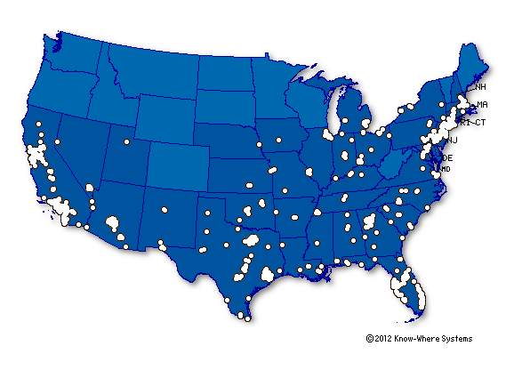**Now, Let’s Jump Right In:**

**The Jump Right InDEX**  
*The New Way of Staying Cool in the Pool Business*

The “Jump Right InDEX” will provide the company with two color-coded maps

1. The first map received by the company will be a five day rating of the swim conditions. The higher the number, the more likely people will be swimming in the week ahead. This map will be emailed to the company every morning.
2. The second map will be an average for the next 30 days. This map will be emailed to the company every two weeks.

This map will help the company make quick and efficient decisions on:

1. How many supplies to order and ship to a region
2. The amount of work-hours to extend to employees in a region
3. The amount of inventory needed for a region
4. Advertising for a region
5. Long term events

These maps will also help make decisions for the following year. So if the store is holding too much inventory and the inventory is experiencing significant depreciation, the company can limit the amount of inventory in that store the following year based on this index. The company can also organize store-to-store shipments if it is needed. The index will be updated daily, always showing a “Next Five Days” trend. The map will take in account the following variables.

What Variables We Account For: In order of importance

1. Local Temperature: *Maximum*
2. Population Density Per Store including tourists: *More people, more pool use, larger volume*
3. Precipitation: *A rainy day will keep people out of the pool*
4. Temperature departure from normal*: In Pennsylvania if it is 70 degrees, people will most likely still swim. However, in Arizona they are cold!*
5. Relative Humidity (above 70 degrees) *: A warm, muggy day would put just about anyone in a pool*
6. Amount of Sunshine : *People are more likely to swim on a sunny day rather than a cloudy one*
7. Average Wind Speed: *Less wind would make better pool weather*
8. How the variables will be weighted in the legend. The higher the addition to index, the more the pool use in that region.
9. Local Temperature: Maximum

|  |  |
| --- | --- |
| Temperature (degree F) | Addition to Index |
| < 65 | 1 |
| 65 - <70 | 5 |
| 70 - <75 | 10 |
| 75 - <80 | 14 |
| 80 - <85 | 16 |
| 85 - <90 | 18 |
| >90 | 20 |

The “Addition to Index” would grow exponentially with increasing temperatures. That is why you see such a higher addition when the temperatures rise into the 70-80’s.

1. Population Density per Store (including tourists): More people, more pool use, larger volume

|  |  |
| --- | --- |
| Population Density per Store (Including Tourists) | Addition To Index |
| >40,000 | 1 |
| 40,001-100,000 | 2 |
| 100,001-250,000 | 4 |
| 250,001-500,000 | 6 |
| 500,001-750,000 | 10 |
| 750,001-1,000,000 | 12 |
| 1,000,001-2,000,000 | 17 |
| 2,000,001-3,000,000 | 18 |
| >3,000,000 | 19 |

1. Precipitation: A rainy day will keep people out of the pool

|  |  |
| --- | --- |
| Chance of Precipitation | Addition to Index |
| 0 | 18 |
| <30 | 15 |
| 30 - <60 | 10 |
| 60 - 90 | 6 |
| >90 | 1 |

1. Temperature departure from normal. In Pennsylvania if it is 70 degrees, people will most likely still swim. However, in Arizona they are cold!

|  |  |
| --- | --- |
| Temperature Departure from Normal (absolute value degree F) | Addition to Index |
| < 5 | 15 |
| 5 | 14 |
| 6 | 13 |
| 7 | 12 |
| 8 | 11 |
| 9 | 10 |
| 10 | 9 |
| 11 | 8 |
| 12 | 7 |
| 13 | 6 |
| 14 | 5 |
| 15 | 3 |
| > 15 | 1 |

The “Addition to Index” would decrease with increasing Temperature departures from normal. Let’s say the normal temperature for the area is around 75 in the oncoming days, but if it’s only 60, then it is cooler than normal. This will keep people out of the pool.

1. 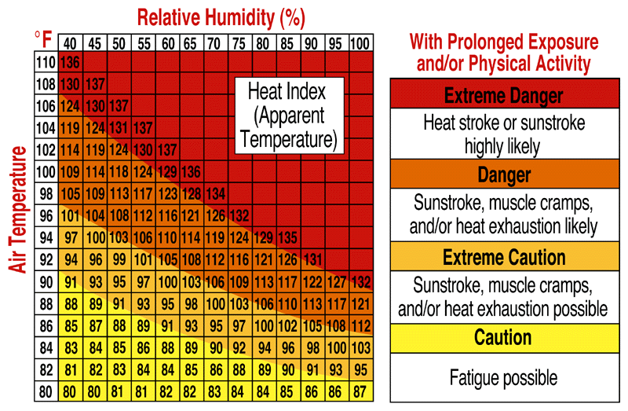Relative Humidity (above 70 degrees) – A warm, muggy day would put just about anyone in a pool. This is only calculated when the maximum temperature is above 70 degrees Fahrenheit.

|  |  |
| --- | --- |
| Relative Humidity When Max Temp Is Above 70 (percentage) | Addition To Index |
| < 30 | 1 |
| 30 - 50 | 5 |
| >50 - 70 | 10 |
| >70 - 90 | 16 |
| >90 - 100 | 20 |

1. Amount of Sunshine – People are more likely to swim on a sunny day rather than a cloudy one.

|  |  |
| --- | --- |
| Cloud Cover | Addition To Index |
| Clear | 15 |
| Scattered | 10 |
| Broken | 5 |
| Overcast | 1 |

1. Average Wind Speed – Less wind would make better pool weather. When there is wind there is a wind chill, which makes the weather feel colder than it actually this. This factor will keep people out of the pool.

**The 5 Day Jump Right InDEX!**

Now a number can be formulated from the weather variables that can let the company know the trends in pool use over the entire country. This will be what makes up the 5 day Jump Right InDEX.

|  |  |
| --- | --- |
| Index Variable | Likeliness of Pool Use |
| 95 - 122 | 100 |
| 85 - 94 | 90 |
| 75 - 84 | 80 |
| 65 - 74 | 70 |
| 55 - 64 | 60 |
| 45 - 54 | 50 |
| 35 - 44 | 40 |
| 25 - 34 | 30 |
| 15 - 24 | 20 |
| 5 - 14 | 10 |
| < 5 | 0 |

**Five Day Index Summary**

An index variable greater than 74 is a high chance of pool use in the forecasted area in the next five days. An index between 25 and 74 is a mild chance of pool use in the area. An index below 25 is a very small chance of pool use in the area.

Pool use can be defined as a single pool’s average use. The chance of a single pool being used more frequently and by more people correlates with increasing pool use. The company will receive the 5-day color – coded map by email every morning. So if there is an urgent need for it, the map will already be produced.

The company will receive the 5-day color – coded map by email every morning. So if there is an urgent need for it, the map will already be produced. This short range forecast would use models like MOS (Model Output Statistics), GFS (Global Forecast System), and NAMM (North American Mesoscale Model). These models are used frequently by Meteorologists and give very detailed and accurate short term forecasts.

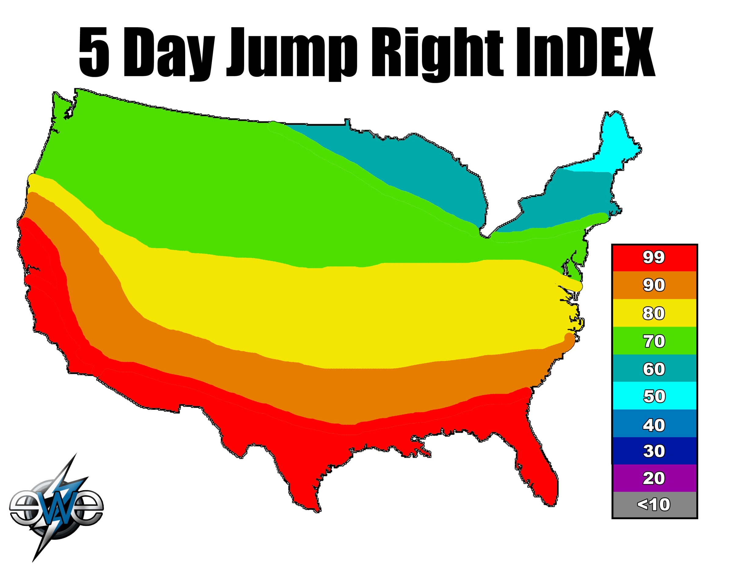

**The 30 Day Jump Right InDEX**

The 30 day Jump Right InDEX will use the averaged values of the maximum temperatures and precipitation for the following 30 day period. These two variables are best for long range forecasting pool us. This Index will be emailed to the company every two weeks.

|  |  |
| --- | --- |
| Index Variable | Likeliness of Pool Use |
| 30 - 38 | 90 |
| 25 - 29 | 70 |
| 20 - 24 | 50 |
| 15 - 19 | 30 |
| 10 - 14 | 20 |
| 5 - 9 | 10 |
| < 5 | 0 |

**30 Day Index Summary**

An index variable greater than 25 is a high chance of pool use in the forecasted area in the next thirty days. An index between 24 and 10 is a mild chance of pool use in the area. An index below 10 is a very small chance of pool use in the area.

Pool use can be defined as a single pool’s average use. The chance of a single pool being used more frequently and by more people correlates with increasing pool use. The company will receive the 30 day color – coded map by email every two weeks. This index will help the company plan the upcoming month by allowing them to use weather as a variable.

This long range forecast would use the Climate Prediction Center (CPC). The CPC only uses temperature and precipitation as long term variables. Therefore, temperature and precipitation are the only two factors calculated into the long term forecast.

The only non – meteorological data included in the map is population density per store (including tourists). This is because pool use is highly dependent on meteorological data; however, population density must be taken into account to properly calculate the volume of supplies needed for that area. If the weather is ideal but the town lacks population, a smaller number of goods will be needed. This variable will help the company become more efficient at calculating population and therefore calculating pool use. It will also give a better understanding of the relationship between population density and weather; two crucial factors that influence the pool business.



























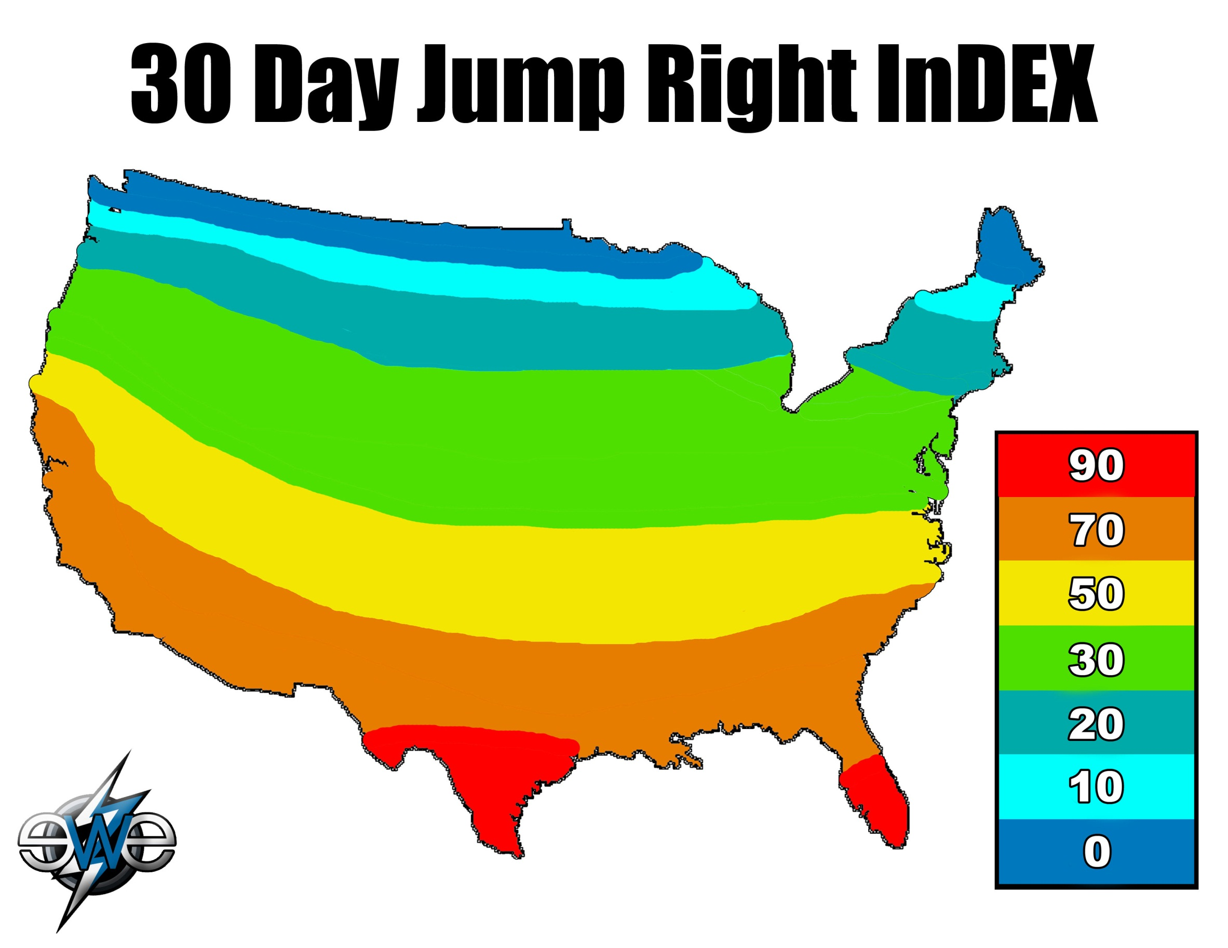

**The 5 Day Specific Region Jump Right InDEX!**

A number can be formulated from the weather variables that can let the company know the trends in pool use in a specified region of Leslie’s choice. This will be what makes up the 5 day specific Jump Right InDEX.

|  |  |
| --- | --- |
| Index Variable | Likeliness of Pool Use |
| 95 - 122 | 100 |
| 85 - 94 | 90 |
| 75 - 84 | 80 |
| 65 - 74 | 70 |
| 55 - 64 | 60 |
| 45 - 54 | 50 |
| 35 - 44 | 40 |
| 25 - 34 | 30 |
| 15 - 24 | 20 |
| 5 - 14 | 10 |
| < 5 | 0 |

**Five Day Specific Region Index Summary**

An index variable greater than 74 is a high chance of pool use in the forecasted area in the next five days. An index between 25 and 74 is a mild chance of pool use in the area. An index below 25 is a very small chance of pool use in the area.

Pool use can be defined as a single pool’s average use. The chance of a single pool being used more frequently and by more people correlates with increasing pool use. The company will receive the 5-day color – coded map of the specific region by email every morning. So if there is an urgent need for it, the map will already be produced.

The company will receive the 5-day color – coded map by email every morning. So if there is an urgent need for it, the map will already be produced. This short range forecast would use models like MOS (Model Output Statistics), GFS (Global Forecast System), and NAMM (North American Mesoscale Model). These models are used frequently by Meteorologists and give very detailed and accurate short term forecasts.

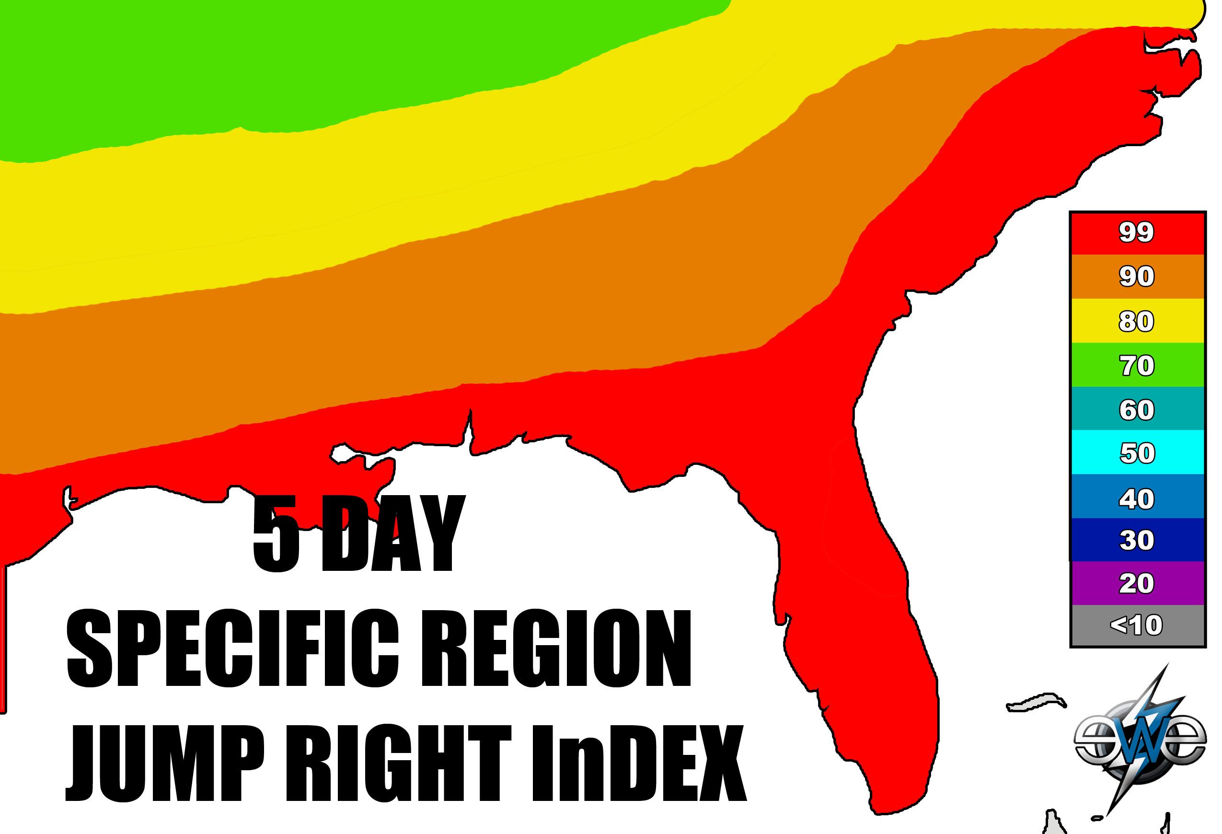

**The 30 Day Specific Region Jump Right InDEX**

The 30 day Specific Region Jump Right InDEX will use the averaged values of the maximum temperatures and precipitation for the following 30 day period in Leslie’s specified region of the country. These two variables are best for long range forecasting pool us. This Index will be emailed to the company every two weeks.

|  |  |
| --- | --- |
| Index Variable | Likeliness of Pool Use |
| 30 - 38 | 90 |
| 25 - 29 | 70 |
| 20 - 24 | 50 |
| 15 - 19 | 30 |
| 10 - 14 | 20 |
| 5 - 9 | 10 |
| < 5 | 0 |

**30 Day Specific Region Index Summary**

An index variable greater than 25 is a high chance of pool use in the forecasted area in the next thirty days. An index between 24 and 10 is a mild chance of pool use in the area. An index below 10 is a very small chance of pool use in the area.

Pool use can be defined as a single pool’s average use. The chance of a single pool being used more frequently and by more people correlates with increasing pool use. The company will receive the 30 day color – coded map of the specific region by email every two weeks. This index will help the company plan the upcoming month by allowing them to use weather as a variable.

This long range forecast would use the Climate Prediction Center (CPC). The CPC only uses temperature and precipitation as long term variables. Therefore, temperature and precipitation are the only two factors calculated into the long term forecast.

The only non – meteorological data included in the map is population density per store (including tourists). This is because pool use is highly dependent on meteorological data; however, population density must be taken into account to properly calculate the volume of supplies needed for that area. If the weather is ideal but the town lacks population, a smaller number of goods will be needed. This variable will help the company become more efficient at calculating population and therefore calculating pool use. It will also give a better understanding of the relationship between population density and weather; two crucial factors that influence the pool business.

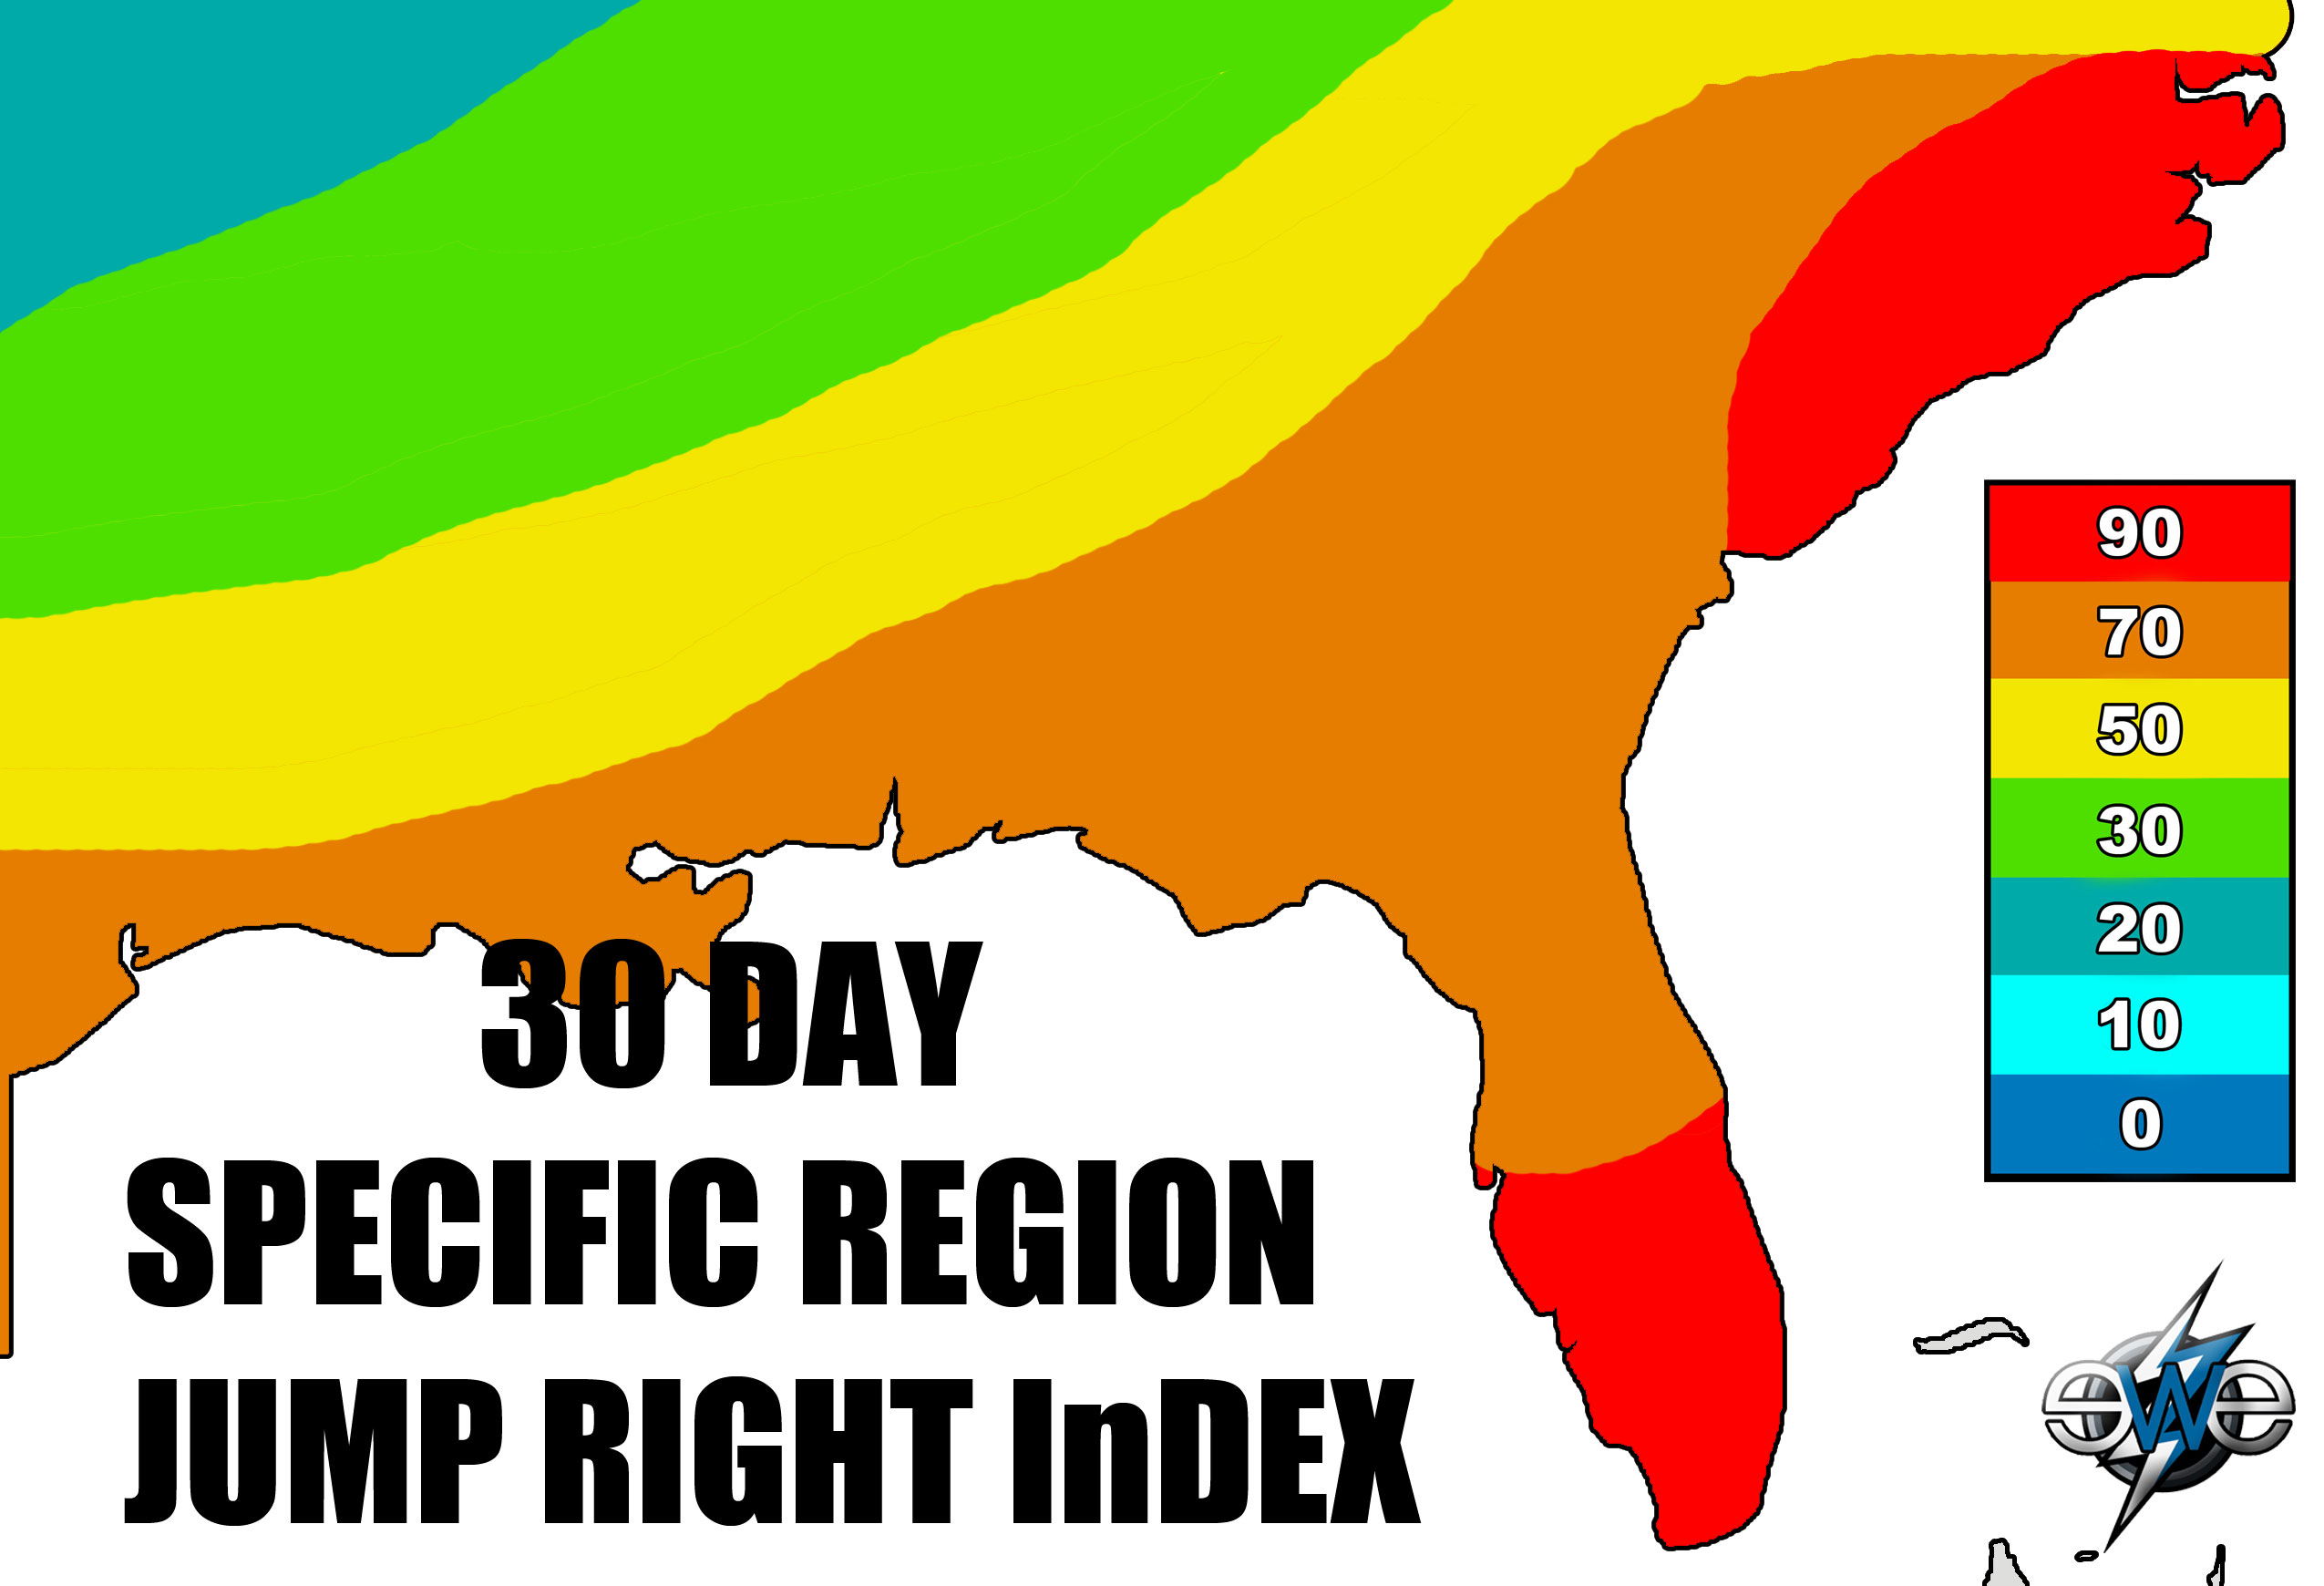

**Thank You**

We appreciate your interest in our new weather index and hope you are interested in using it in your everyday business strategy. Like we said before, we believe that weather can make or break a business. Let us help you and together, we can make a difference in the pool industry. Let’s jump right in!

***Contract***

There are going to be several offers you can choose from to fit your needs. Before any packages are purchased, a one, two, or four year agreement must be purchased.

1 year agreement--$10,000

2 year agreement--$20,000

4 year agreement--$30,000

Package 1: 5 day nationwide index forecast-------$40,000

Cost Breakdown: Labor $30,000/ $5,000 Technology and Web Development/ $5,000 Research and Development

Package 2: 5 day specific region index forecast-------$35,000

Cost Breakdown: Labor $25,000/ $5,000 Technology and Web Development/ $5,000 Research and Development

Package 3: 30 day nationwide index forecast-------$30,000

Cost Breakdown: Labor $20,000/$5,000 Technology and Web Development/

$5,000 Research and Development

Package 4: 30 day specific region index forecast-------$25,000

Cost Breakdown: Labor $15,000/ $5,000 Technology and Web Development/ $5,000 Research and Development

Package 5: 5 and 30 day nationwide index forecasts-------$50,000

Cost Breakdown: Labor $40,000/ $5,000 Technology and Web Development/ $5,000 Research and Development

Package 6: 5 and 30 day for specific region index forecasts-------$45,000

Cost Breakdown: Labor $35,000/ $5,000 Technology and Web Development/ $5,000 Research and Development

Package 7: 5 and 30 day nationwide and highly detailed

regional index forecasts -----$75,000

Cost Breakdown: Labor $60,000/ $8,000 Technology and Web Development/ $7,000 Research and Development

All prices are non-negotiable. In the event that this index does not do all of the things it is expected to do *Elite Weather Enterprises* is not held accountable due to the fact that extreme weather events are likely to occur.

Works Cited

Australian Government. *Mean Modulus Error*. Digital image. *Australian Government Bureau of Meteorology*. 1 Jan. 2011. Web. 13 Jan. 2012.

<http://www.google.com/imgres?q=mean+modulus+temperature&>

"Atmospheric Scientists." *U.S. Bureau of Labor Statistics*. Web. 31 Jan. 2012. <http://www.bls.gov/oco/ocos051.htm>.

"ForecastAdvisor Weather Forecast Accuracy Blog: Accuracy of Temperature Forecasts." *Weather Forecast and Weather Forecast Accuracy for Your City*. Web. 21 Jan. 2012. <http://www.forecastadvisor.com/blog/2006/09/24/accuracy-of-temperature-forecasts/>.

Leslie’s Poolmart Inc. Annual Financial Report

"National Hurricane Center Forecast Verification." *National Hurricane Center*. Web. 31 Jan. 2012. <http://www.nhc.noaa.gov/verification/verify5.shtml>.

"Spas & Hot Tubs." *Leslie's Swimming Pool Supplies, the World Leader in Residential and Commercial Pool Supplies.* Web. 22 Jan. 2012. <http://www.lesliespool.com/Home/Spas-and-Hot-Tubs.html>.

"Summer Weather Safety Week." *National Weather Service - Central Region Headquarters Home Page*. Web. 23 Jan. 2012. <http://www.crh.noaa.gov/lsx/?n=summerweathersafetyweek>.