Jacqueline Layer
Meteo 482- Investigative Phase
Forensic Case 5

Introduction:

I have been requested by Paul Knight to provide an estimate of the rainfall in the Conocoheague Creek basin in Franklin County, Pennsylvania for the morning of May 12, 2008. A storm had passed through the area that caused a power outage, which caused the stream gauge to stop reporting. I was specifically asked to report on if the data obtained from the WSR-88D rainfall estimates supports the claim that the streams ran over their banks in Franklin County on this day.

Assumptions:

To make a good estimate of the rainfall that fell, one must become familiar with the area where the event occurred. In the first map, I have provided a map of Pennsylvania with Franklin County highlighted
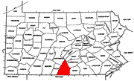
Franklin County is part of the Potomac River Sub-Basin (pictured below on the right), in which Conocoheague Creek watershed is apart of as shown highlighted in light blue in the picture below on the right.
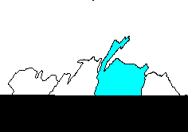
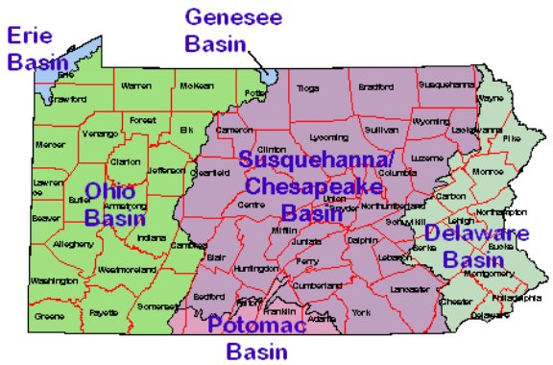
To provide the most accurate estimate, I am going to assume that most of the water that falls in Franklin County and in surrounding counties will end up in the Conocoheague Creek basin.

Data Sources Used:

I used the Doppler Radar data from the State College, PA NEXRAD for May 12, 2008 provided by NCDC (National Climate Data Center). I looked at both reflectivity as well as rainfall totals. Included are the paper color prints of the rainfall totals from this day, one at 9:00am and one at 1:00pm.
Methodology:

Doppler Radar scans the skies to detect precipitation every five minutes with a conical shaped beam. The beam can reach about 125 mile radius around the radar site considering the earth is sphere shaped and the angle of the beam is 0.5 degrees. Considering that Franklin County is about 80 miles south of State College, PA (where the radar is located), it is safe to say that the radar is capable of giving a good estimation of the amount of rainfall that fell over the area based on reflectivity.

Limitations:

Some limitations that could affect the proper amount of rainfall are geographical obstructions to the beam, and hail. Some geography like mountains could block the beam from reaching the anticipated distance it is suppose to cover, and causes precipitation to appear more intense on the radar. This also occurs when a storm produces hail. Hail is bigger and denser than raindrops, which causes the beam to reflect back a stronger beam. This registers more intense precipitation. The radar is unable to decipher between hail and heavy precipitation, and therefore can produce another inaccurate reading.

With this case, considering the geography between State College and Franklin County, PA is generally flat and a hail-producing thunderstorm did not occur that day, it is safe to say that the rainfall amounts produced by the radar are accurate and reasonable.

Summary of Events:

Weather Synopsis for the morning and early afternoon of May 12. 2008

According to the Doppler Radar data obtained from NCDC, the rainfall began to fall in the northeastern part of Franklin County around 4:00am EDT. Continuing to go through the data, an inch of rain had already fallen by 9:00am in this area and nearly an inch of rain had fallen throughout the whole county by this time. The rain ended between 1:00pm and 2:00pm. The northern part of Franklin County got about an inch of rain while the southern region saw less rainfall with about 0.8 inches of rain. The heavier rain stayed to the north of the region. I have attached the radar used, which shows the rainfall totals. The brown lines are the county boundaries, blue lines indicate the watershed boundaries, and the key is presented to you on the side of the radar. The first map is from 9:00am and the second map is from 1:00pm when the rainfall began to dissipate.

Conclusions:

Looking over the data obtained from NCDC, approximately an inch of rain fell over the area being investigated, the Conocoheague Creek Basin. This rain even lasted about nine hours. Also, knowing that other waterways and creeks flow into the Conocoheague Creek and considering most of the heavier rain stayed to the north (about 1.5 inches fell just north-northeast of the county). With the amount of rain that fell in the short time span and the fact that streams and creeks flood faster than rivers because they cannot handle as much water, I can conclude that it is likely that the streams and creeks in Franklin County ran over their banks the morning of May 12, 2008 as well as into the afternoon hours.

The conclusions stated above represent my professional evaluation of the meteorological conditions surrounding the estimated rainfall amounts over the Conocoheague Creek basin in Franklin County, Pennsylvania on May 12, 2008.

Jacqueline Layer

